WIJAYAWARDHANA W.A.H.A.

2019/E/166

SEMESTER 05

03 SEPTEMBER 2022

DATA COLLECTIONS – LAB 02

EC 5080

SOFTWARE CONSTRUCTION

QUESTION 01:

PART 01:

02.

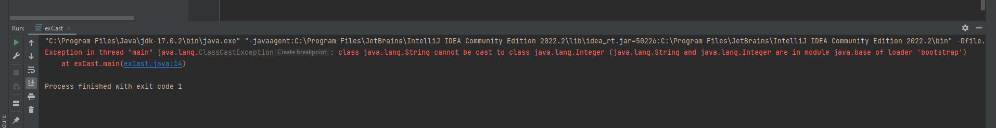

Here we can get a run time error because the casting did not happen properly. According to the compiler the error is detected on int x = (Integer) strCast.getData(); line.

03.

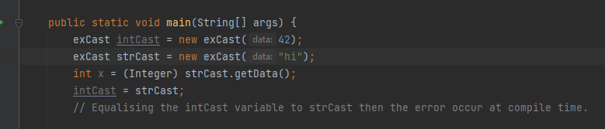

When intCast = strCast line added at the end it will give compile time error.

04.

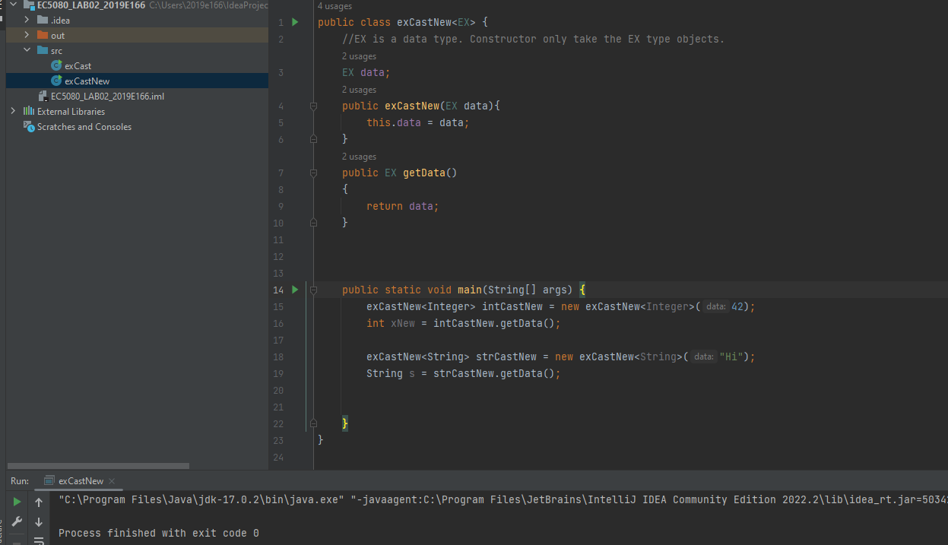

PART 02

01.

//https://big-o.io/examples/bubble-sort/java-generic/ - get the idea for object comparison.  
public class BS {  
 public static<**E** extends Comparable<**E**>> void BS(**E** [] arr)  
 {  
 boolean Pass = true**;** //fill  
 int n = arr.length**;** for (int i = **0;** i < n && Pass**;** i++)  
 {  
 Pass = true**;** //fill  
 for (int j = **0;** j < n - i-**1;** j++)  
 {  
 if ((arr[j].compareTo(arr[j+**1**]) > **0**))  
 {  
 *swap*(j**,**j+**1,**arr)**;** Pass = true**;** }  
 }  
 }  
 }  
 public static void swap(int i **,** int j**,**Object [] arr)  
 {  
 Object temp = arr[i]**;** arr[i] = arr[j]**;** arr[j] = temp**;** }  
 public static void print(Object arr[])  
 {  
 int i = **0;** while(i < arr.length)  
 {  
 System.*out*.print(arr[i] + " ")**;** i++**;** }  
 System.*out*.println()**;** }  
 public static void main(String args[])  
 {  
 Integer[] intArray = {**34,6,7,5,32,77,78,55**}**;** Double[] doubleArray = {**5.7,89.8,43.0,42.5,2.4,1.5**}**;** String[] stringArray = {"alpha"**,**"gamma"**,**"beta"**,**"delta"}**;** *BS*(intArray)**;** *BS*(doubleArray)**;** *BS*(stringArray)**;** *print*(intArray)**;** *print*(stringArray)**;** *print*(doubleArray)**;** }  
}

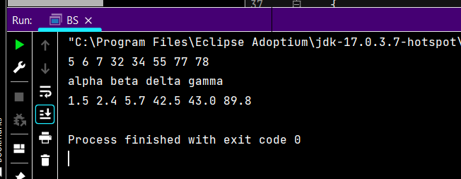

QUESTION 02:

01.

a. Set

b.

// I certify the code of this lab is entirely my own work, but I referred the lecture notes attached.

import java.util.LinkedHashSet;

import java.util.Set;

public class FindDuplicateElements {

public static void main(String[] args) {

int[] data = {11,34,22,67,11,3,54,13,34,90,3,46};

Set<Integer> set = new LinkedHashSet<Integer>();

Set<Integer> duplicateSet = new LinkedHashSet<Integer>();

int j = 0;

for(int i =0; i< data.length; i++)

{

set.add(data[i]);

if((j+1) == set.size())

{

j++;

}

else

{

duplicateSet.add(data[i]);

}

}

System.out.println(set);

System.out.println("Duplicate : "+duplicateSet);

}

}

c.

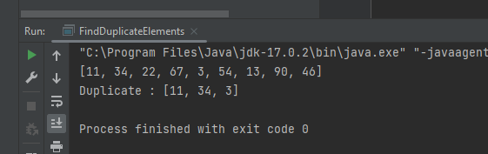

02.

a. List

b.

*/** I certify the code of this lab is entirely my own work,  
 * https://www.geeksforgeeks.org/sort-string-characters/ this helps to get an idea about sorting strings.  
 */*import java.util.Arrays**;**import java.util.LinkedList**;**import java.util.Random**;**public class Cards {  
  
 LinkedList cards = new LinkedList<String>()**;** public void setCards(Object[] cardsArray)  
 {  
 for(int i =**0;** i<cardsArray.length**;** i++)  
 {  
 cards.add(cardsArray[i])**;** }  
 System.*out*.println("Added")**;** }  
 public void SortTheCard(Object[] cardsArray)  
 {  
 Arrays.*sort*(cardsArray**,0,**(cardsArray.length))**;** System.*out*.println("Sorted card : ")**;** for(int i =**0;** i<cardsArray.length**;** i++)  
 {  
 System.*out*.print(cardsArray[i] + " ")**;** }  
 System.*out*.println()**;** }  
  
  
 public void shuffleTheCards()  
 {  
 System.*out*.println("Shuffle the cards : ")**;** for(int i =**0;** i<cards.size()**;** i++)  
 {  
 int s = new Random().nextInt(cards.size())**;** System.*out*.print(cards.get(s) + " ")**;** }  
 System.*out*.println()**;** }  
  
 public void reverseTheCards()  
 {  
 System.*out*.println("Reverse Order : ")**;** for (int i = cards.size()**;** i>**0;** i--)  
 {  
 System.*out*.print(cards.get(i-**1**)+" ")**;** }  
 System.*out*.println()**;** }  
  
 public static void main(String[] args) {  
 String[] cardArray = {"ClubsA"**,**"SpadeK"**,**"HeartsQ"**,**"DiamondJ"**,**"Clubs10"**,**"Spade9"**,**"Hearts8"**,**"Diamond7"**,**"Clubs" +  
 "6"**,** "Spade5"**,**"Hearts4"**,**"Diamond3"}**;** Cards object = new Cards()**;** object.setCards(cardArray)**;** object.SortTheCard(cardArray)**;** object.shuffleTheCards()**;** object.reverseTheCards()**;** object.shuffleTheCards()**;** }

c.

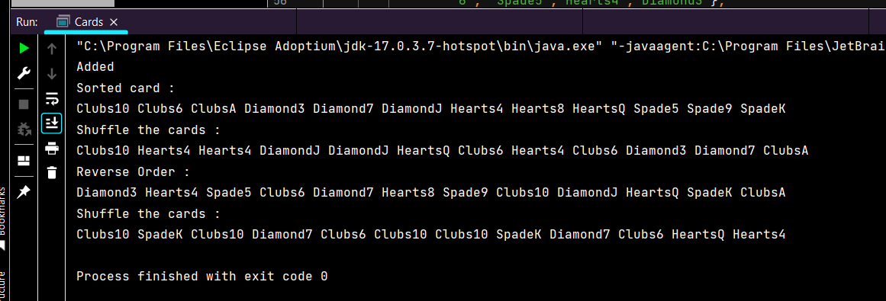

03.

1. Map
2. import java.util.*;

public class NumberOfOccurences {

Scanner scanner = new Scanner(System.in);

public void divideWord()

{

System.out.println("Enter the sentence : ");

String sentence = scanner.nextLine();

String[] word = sentence.split(" ");

HashMap<String,Integer> wordDetails = new HashMap<>();

for (int i =0; i<word.length; i++)

{

String temp = word[i];

wordDetails.put(temp,temp.length());

}

System.out.println(wordDetails);

}

public static void main(String[] args) {

NumberOfOccurences object = new NumberOfOccurences();

object.divideWord();

}

}

c.

